Final Year Design Project System Requirement Specification

AI-Powered Smart Road Visibility & Hazard Detection System Proposal

Final Year Design Project SRS

by

ZARTASHA ANSARI BCS22001
ISBA BCS22003
NOOR-E-HIRA BCS22018
IFRA KASHIF BCS22020

Project Advisor:

Department of Information Technology
University Of Punjab, Gujranwala Campus, Gujranwala, Pakistan
(2025)

AI-Powered Smart Road Visibility & Hazard Detection System for Smog and Fog Conditions

Executive Summary:

This project proposes the development of an AI-Powered Smart Road Visibility & Hazard Detection System, a low-cost, computer vision-based solution specifically designed to mitigate the high incidence of road accidents caused by severe winter smog in Pakistani urban environments. The existing gap is the lack of affordable, real-time driver assistance systems optimized for the visual degradation caused by dense, localized particulate matter. This system strategically eliminates the technical risk of monocular distance estimation and Time-to-Collision (TTC) calculation, focusing instead on Visibility Quantification and Hazard Identification. The methodology involves leveraging a pre-trained YOLOv8 model for low-contrast obstruction detection, coupled with specialized image processing techniques (dehazing/contrast) for Visibility Scoring. The primary objectives are to achieve a reliable Visibility Meter (e.g., Good/Moderate/Critical) and maintain a processing speed of 15–30 FPS on standard consumer hardware. The expected outcome is a high-impact, socially relevant prototype that provides immediate, actionable safety data to drivers during smog events.

Table of Contents
Executive Summary: 2
1. Requirement Analysis: 5
1.1. User Classes and Characteristics: 5
1.2. Requirement Identifying Techniques: 5
1.3. Functional Requirements: 6
1.3.1. Feature 1: User Authentication(Login): 6
1.3.2. Feature 2: Real-Time Dehazing and Visualization: 6
1.3.3. Feature 3: Visibilty Meter: 7
1.3.4. Feature 4: Hazard Detection: 7
1.3.5. Feature 5: UI Customization: 8
1.3.6. Feature 6: Data Logging: 8
1.3.7. Feature 7: Audio Customization: 8
1.4. Non-Functional Requirements: 9
1.4.1. Reliability: 9
1.4.2. Usability: 9
1.4.3. Performance: 10
1.4.4. Accuracy: 10
1.4.5. Optimization and Resource Efficiency: 10
1.4.6. Security: 10
1.5. External Interface Requirements: 11
1.5.1. User Interface Requirements: 11
1.5.2. Software Interfaces: 12
1.5.3. Hardware Interfaces: 13
1.5.4. Communication Interfaces: 13
2. Use Case Analysis: 14
2.1. Use Case 1: Monitor Real-Time Visibility: 14
2.2. Use Case 2: Alert Driver to Critical Hazard: 15
2.3. Use Case 3: Configure Safety Settings: 16
2.4. Use Case 4: Manage Trip Data Logging: 16
2.5. Use Case Diagram: 17
3. StoryBoard: 18
4. Summary: 20
5. References: 20

List of Tables

Table 1 : User Classes and Characteristics 5
Table 2 : Feature 1(User Authentication) 6
Table 3 : Feature 2(Real-time Dehazing) 6
Table 4 : Feature 3(Visibility Meter) 7
Table 5 : Feature 4(Hazard Detection) 7
Table 6 : Feature 5(UI Customization) 8
Table 7 : Feature 6(Trip Data Logging) 8
Table 8 : Feature 7(Audio Customization) 8
Table 9 : UseCase 1(Monitoring Real Time Visibility,UC1) 14
Table 10 : UseCase 2(Alert Drivers to Critical Hazards,UC2) 15
Table 11 : UseCase 3(Configure Safety Settings,UC3) 16
Table 12 : UseCase 4(Manage Trip Data Logging,UC4) 16

List of Figures

Figure 1 : Use Case Diagram 17
Figure 2 : Storyboard 18

Requirement Analysis:

User Classes and Characteristics:
Table 1: User Classes and Characteristics
User Class | User Characteristics
Private Commuter | Frequency: Daily (Morning/Evening commute).  Tech Skill: Low to Medium.  Key Needs: Simple UI, clear audio/visual alerts, non-distracting interface. Interested in personal safety and reaching destinations without accident-related delays .
Commercial Driver (Logistics) | Frequency: High (Long hours on highways/GT Road).  Tech Skill: Low.  Key Needs: High reliability, minimal interaction required while driving. Interested in avoiding collisions to protect fleet vehicles and reduce insurance costs .
Traffic Authority / Administrator | Frequency: Occasional (Data Review).  Tech Skill: Medium to High.  Key Needs: Access to trip logs and visibility data. Interested in aggregating data to monitor smog severity and accident trends for public safety policy .

Requirement Identifying Techniques:
To derive the functional requirements for the AI-Powered Smart Road Visibility System, we utilized the following techniques:
- Document Analysis :
We analyzed the initial Project Proposal and existing literature on road safety in Pakistan to identify the critical gaps in current solutions . This helped us establish the core constraints, such as the need for low-cost hardware and the specific environmental challenge of smog versus normal fog.
- Use Case Analysis :
As this is an interactive end-user application, Use Case Analysis was selected as the primary technique . We identified the primary actors (Private Commuter, Commercial Driver) and mapped out their interactions with the system in various scenarios. This allowed us to define specific system behaviors, such as how the interface should react when visibility drops to "Critical" levels or when a hazard is detected.
- Storyboarding:
To ensure the user interface is non-distracting for drivers, we utilized Storyboarding . This involved sketching the sequence of screens—from the Splash Screen to the Main Dashboard—to visualize the flow of events and the placement of critical warnings like the Visibility Meter.

Functional Requirements:

Feature 1: User Authentication(Login):
This Feature will start a session with the user . This is a new Feature we added.
Table 2: Feature 1(User Authentication)
Field | Description
Identifier | FR-1
Title | User Login and Session Management
Requirement | The system shall provide a login screen requiring a valid Username and Password before granting access to the main dashboard. Upon successful login, the system shall initiate a "Trip Session" to log visibility data.
Source | Project Team (New Requirement)
Rationole | To secure the application and associate trip data (visibility levels, hazards encountered) with specific users for future analysis by authorities.
Priority | Medium

Feature 2: Real-Time Dehazing and Visualization:
This Feature will cover the “Dehazed Video” and our “Main Screen”.

Table 3: Feature 2(Real-time Dehazing)
Field | Description
Identifier | FR-2
Title | Real-Time Video Dehazing and Display
Requirement | The system shall capture live video from the connected camera and apply an image enhancement algorithm (dehazing/contrast adjustment) to the frames. The processed "clearer" video must be displayed on the Main Dashboard with a latency of less than 100ms.
Source | Proposal Objectives (Visibility Quantification)
Rationale | Drivers cannot see through smog; the system must digitally "clean" the image to reveal road details that the human eye might miss.
Priority | High

Feature 3: Visibilty Meter:
This Feature corresponds to our Project’s “Visibility Quantification” Objective.
Table 4: Feature 3(Visibility Meter)
Field | Description
Identifier | FR-3
Title | Real-Time Visibility Scoring and Display
Requirement | The system shall analyze the video frame to calculate a Visibility Score based on contrast and fog density. This score must be displayed on the Main Dashboard as a graded status (e.g., "Good," "Moderate," "Critical") updated at least once per second.
Source | Proposal Objectives (Visibility Quantification) 2
Rationale | Drivers need an objective measure of safety, as human eyes adjust slowly to worsening conditions.
Priority | High

Feature 4: Hazard Detection:
This Feature corresponds to our Project’s “Hazard Detection” Objective.
Table 5: Feature 4(Hazard Detection)
Field | Description
Identifier | FR-4
Title | Low-Contrast Obstacle Detection
Requirement | The system shall use the optimized YOLOv8 model to detect vehicles, pedestrians, and large obstacles. When a hazard is detected, the system must draw a bounding box around the object on the Main Dashboard and trigger an audio warning if the object is within a critical range.
Source | Proposal Objectives (Hazard Detection Accuracy) 4
Rationale | To prevent collisions with stationary or slow-moving objects that are invisible in smog.
Priority | High

Feature 5: UI Customization:
This Feature will allow the user to Change the UI themes and fonts to increase readability.
Table 6: Feature 5(UI Customization)
Field | Description
Identifier | FR-5
Title | UI Customization (Font & Theme)
Requirement | The system shall provide a Settings Menu that allows the user to:  - Toggle between Light Mode and Dark Mode (Night Mode).  2. Adjust the Font Size of warning text (Small, Medium, Large) for better readability.
Source | User Request (Accessibility Features)
Rationale | To ensure the driver is not blinded by a bright screen at night and can read warnings quickly without squinting.
Priority | Low

Feature 6: Data Logging:
This new Feature will cover the Database/Logging that can be used by Traffic Authorities for smog Severeity and Accidents ration for public safety Policy.
Table 7: Feature 6(Trip Data Logging)
Field | Description
Identifier | FR-6
Title | Trip Data Logging
Requirement | The system shall maintain a local database to store "Trip Logs." Each log must record the Date, Time, Duration, and number of "Critical Visibility" events encountered. This data shall be accessible to the user (and authorities) via a "History" tab.
Source | Stakeholder Interest (Government/Traffic Police) 5
Rationale | To provide valuable data on smog severity and accident risks to government authorities for safety auditing.
Priority | Medium

Feature 7: Audio Customization:
Table 8: Feature 7(Audio Customization)
Field | Description
Identifier | FR-7
Title | Audio Alert & Voice Tone Customization
Requirement | The system shall provide an Audio Settings module that allows the user to:  - Select Voice Gender: Toggle between Male and Female voice profiles.  - Adjust Voice Tone/Pitch: Modify the pitch frequency (Low/Deep to High/Sharp) to suit hearing preference.  - Select Alert Style: Choose between "Assertive" (faster, louder) or "Calm" (slower, softer) speaking styles.  4. Test Audio: Play a sample warning message to verify the selected tone.
Source | User Request (Accessibility & UX Enhancement)
Rationale | To prevent "alarm fatigue" and ensure the audio warning is distinct and audible for drivers with varying hearing capabilities (e.g., presbycusis).
Priority | Low (Enhancement)

Non-Functional Requirements:
Non-Functional Requirements define how well the system performs.

Reliability:
- Availability:
The system shall operate continuously without crashing for the duration of a typical commute (up to 4 hours).
- Fail-Safe:
If the camera disconnects, the system shall display a distinct "Signal Lost" error message and automatically attempt to reconnect every 5 seconds.

Usability:
- Readability:
All warning text (e.g., "CRITICAL") must be legible from a distance of 60cm (typical driver-to-dashboard distance).
- Minimal Distraction:
The interface shall utilize a "Dark Theme" by default during night hours to prevent cabin glare.
- Ease of Use:
The "Login" to "Live Tracking" workflow should require no more than 3 clicks.

Performance:
- Frame Rate:
The system shall process video and generate alerts at a rate of 15–30 Frames Per Second (FPS) on a standard laptop with a dedicated GPU (or optimized CPU).
- Latency:
The time delay between a real-world event and the system alert shall not exceed 200 milliseconds.

Accuracy:
- Detection Precision:
The YOLOv8 model shall achieve a Detection Accuracy of 85–90% for identifying vehicles and pedestrians in low-contrast (smoggy) video feeds .
- False Positive Rate:
The system shall minimize false alarms (detecting a ghost as a car) to ensure drivers do not lose trust in the system. The false positive rate should be less than 10%.
- Visibility Scoring Accuracy:
The Visibility Meter must correctly categorize the environment (Good vs. Critical) consistent with visual density metrics in at least 90% of test cases .

Optimization and Resource Efficiency:
- Hardware Compatibility:
The system shall be optimized to run on standard consumer hardware (e.g., a laptop with Core i5 and 8GB RAM) without requiring a high-end dedicated GPU .
- Model Size:
The deployed AI model (likely YOLOv8 Nano or Small) shall be optimized (quantized) to ensure it loads into memory in under 5 seconds.
- CPU Usage:
The application shall not consume more than 70% of available CPU resources to prevent the host laptop from overheating or freezing during a drive.

Security:
- Data Privacy:
User passwords for the Login feature shall be hashed (encrypted) before being stored in the local database.
- Access Control:
Access to the "Trip History" logs shall be restricted to authenticated users only.

External Interface Requirements:

User Interface Requirements:
The user interface (UI) is designed to be high-contrast and minimal to ensure driver safety. The system shall rely on a Dark Mode aesthetic by default to minimize cabin glare during low-visibility conditions. The interface consists of four primary screens:
Splash Screen(Startup):
- Visuals:The screen shall display the project logo centered on a black background.
- Behavior:A progress bar shall indicate the loading status of the AI models (e.g., "Loading YOLOv8 weights...", "Initializing Dehazing Module...").
- Transition:Upon 100% loading, the system shall automatically transition to the Login Screen.
Login and Registeration Screen:
- Input Fields: Some text fields for Username and Password(and other Credentials).
- Controls:A "Login" button and a "Register New User" link.
- Validation:The system shall display an error message in red text ("Invalid Credentials") if authentication fails against the local SQLite database.
Main Dashboard(The Driving Mode):
This is the primary interface used while driving. It shall be divided into three logical zones:
- Zone A: Live Video Feed(Background):
  - The entire window background shall render the Dehazed Video Stream processed by OpenCV.
  - Augmented Reality Overlays: Detected hazards (Vehicles, Pedestrians) shall be highlighted with Red Bounding Boxes (RGB: 255, 50, 50).
  - Labels: Each box shall display the class name and confidence score (e.g., "Car: 92%") in white text with a black background for readability.
- Zone B: Visibility Meter: (Top-Right HUD):
  - A semi-transparent Heads-Up Display (HUD) panel showing the current status.
  - Large, bold text indicating status: "GOOD" (Green), "MODERATE" (Yellow), or "CRITICAL" (Red).
- Zone C: Status Bar:
  - Displays technical metrics: FPS Counter (e.g., "32 FPS"), System Time, and Audio Status (Mute/Unmute icon).
Setting Interface:
A modal window accessible via the 'Settings' button or 'S' hotkey, containing the following tabs:
- General: Toggle Theme (Light/Dark/High Contrast).
- Typography: You can Change Font Size (14pt - 36pt) and Font Weight (Normal/Bold) and Font Style for all warning text.
- Audio Management:
  - Voice Gender: Radio buttons for [Male / Female].
  - Tone/Pitch: A slider (0.5x to 1.5x) to adjust the pitch of the warning voice.
  - Volume: Audience can change the Volume based on their needs. (0% - 100%).

Software Interfaces:
The system acts as an integrator between raw camera data and deep learning models. The specific software interfaces and their versions are defined below:
Operating System:
- Compatibility:The software shall be compatible with Windows 10/11 (64-bit) and Linux (Ubuntu 20.04 LTS).
Programming Language and Interpreter:
- Python 3.8+: The core logic is executed via the Python interpreter. The system relies on Python's Global Interpreter Lock (GIL) management for threading the video capture and inference processes.
Commputer Vision Libraries:
- OpenCV(cv2)v4.8+: Interfaces with the camera hardware to capture frames. It is also responsible for the Image Processing Pipeline (converting RGB to HLS color space for contrast enhancement and dehazing algorithms).
Deep Learning Backend:
- Ultralytics YOLOv8:The system interfaces with the ultralytics Python package. It loads the custom-trained .pt (PyTorch) weight file.
- PyTorch v2.0+: It will Serve as the calculation backend for tensor operations required by YOLOv8.
Database Management:
- SQLite3: A serverless, self-contained SQL database engine. The system interfaces with a local file (e.g: smog_project.db) to execute SQL queries for SELECT (User login),INSERT (Logging trip data and visibility events) and etc.

Hardware Interfaces:
The software interacts directly with the host machine's peripherals.
Video Input Interface:
- Device Support:The system shall support USB Webcams (2.0/3.0) and CSI Cameras (if on Raspberry Pi/Linux).
- Protocol:The system shall interface via DirectShow (on Windows) or V4L2 (Video4Linux2 on Linux).
- Input Constraints:The system requires a video stream with a minimum resolution of 640x480 (VGA). It will automatically request the MJPEG codec from the camera to reduce USB bandwidth latency.
Audio Output Interface:
- Driver: The system shall interface with the OS's default audio driver (e.g., PulseAudio on Linux, WASAPI on Windows).
- Hardware: It utilizes the host laptop's built-in speakers or connected AUX/Bluetooth output for generating warning tones (Beeps) and Text-to-Speech voice alerts.

Communication Interfaces:
Although the system is designed for offline safety, it includes specific data interfaces for reporting:
Logical Data Logging:
- The system generates internal communication between the "Detection Module" and the "Database Module."
- It will use protocol like Standard SQL queries over local file I/O.
Report Export:
- The system shall provide an interface to export Trip Logs into standard formats.
- Format: .CSV (Comma Separated Values) for statistical analysis by Traffic Authorities.
- Content: The exported file will contain columns for: Timestamp, GPS-Coordinates (if available), Average Visibility Score, and Hazard Count.

Use Case Analysis:

Use Case 1: Monitor Real-Time Visibility:
Table 9: UseCase 1(Monitoring Real Time Visibility,UC1)
UC Identifier | UC1
Requirements Traceability | FR-2, FR-3, FR-4
Purpose | To continuously process the camera feed, quantify the smog density, and display the current Visibility Score on the dashboard to the driver.
Priority | High
Preconditions | The user is authenticated/logged in. The system application is open and initialized. The camera feed is active and providing frames.
Post conditions | The Main Dashboard is actively displayed, showing the real-time video feed and the updated Visibility Meter (FR-3).
Actors | Primary Driver, Commercial Driver, External Camera
Extends | N/A
Main Success Scenario | - The Driver views the Main Dashboard, initiating the monitoring loop.  - System captures a new frame from the External Camera (FR-2).  - System applies image enhancement algorithms (dehazing/contrast) to the frame.  - System calculates the Visibility Score based on image features and updates the score.  - System displays the score on the Visibility Meter (e.g., "Good," "Moderate," or "Poor").  6. System repeats the process starting from Step 2, maintaining 15-30 FPS (FR-4).
Alternate Flow | Low FPS: If processing speed drops below 15 FPS (NFR-Performance), the system displays a  warning message to the user/administrator.
Exception | Camera Disconnect:  If the video stream stops, the system displays a distinct "Signal Lost" error and automatically attempts to reconnect every 5 seconds (NFR-Fail-Safe).
Includes | Real-Time Video Processing

Use Case 2: Alert Driver to Critical Hazard:
Table 10: UseCase 2(Alert Drivers to Critical Hazards,UC2)
UC Identifier | UC2
Requirements Traceability | FR-3, FR-4, FR-7
Purpose | To provide an immediate, high-priority audio and visual warning when a critical low-contrast hazard is detected or visibility drops below the safety threshold.
Priority | High
Preconditions | UC1 is successfully running and providing Visibility Scores (FR-3). Hazard Detection Module (YOLOv8) is initialized and running (FR-4).
Post conditions | The hazard event is logged; the system returns to the continuous monitoring state (UC1).
Actors | Primary Driver, Commercial Driver
Extends | Monitor Real-Time Visibility (UC1)
Main Success Scenario | - UC1 is running, and the Visibility Score is "Poor."  2. Hazard Detection Module (YOLOv8) identifies a low-contrast obstacle (e.g., stopped car/pedestrian) within the critical zone.  3. System initiates Audio Alert (voice tone "Immediate hazard detected!") and Visual Alert (flashing red boundary, bounding box) (FR-7).  4. Alert persists until the hazard leaves the frame or the driver manually dismisses the alert.  5. System logs the hazard event details (location, time) to the Trip Data Log (FR-6).
Alternate Flows | Visibility Threshold Alert: If Visibility Score drops to "Critical" (e.g., below 50 meters) but no specific hazard is detected, the system triggers a continuous "Critical Visibility Warning" (less intense visual/audio) until the score improves.
Exception | False Positive Alert: If the alert is triggered by non-obstacle interference (e.g., a glare), the driver can hit the 'Mute' button, logging the event as a suspected false positive.
Includes | N/A

Use Case 3: Configure Safety Settings:
Table 11: UseCase 3(Configure Safety Settings,UC3)
UC Identifier | UC3
Requirements Traceability | FR-5, FR-7
Purpose | To allow the user (Driver or Administrator) to adjust safety thresholds, display themes, and audio output preferences.
Priority | Medium
Preconditions | User is authenticated. The system is paused or running in the background.
Post conditions | New settings are saved to the local configuration file and applied immediately upon returning to the Main Dashboard.
Actors | Primary Driver, System Administrator
Extends | N/A
Main Success Scenario | - User selects the Settings Menu option.  - User navigates to the Audio Management tab.  - User modifies the Voice Pitch (FR-7) via a slider and plays a sample warning message.  - User navigates to the General tab and toggles the UI to Dark Mode (FR-5).  - User clicks "Save & Exit."  6. System saves settings and returns to the Main Dashboard, applying the new configuration.
Alternate Flows | Invalid Input: If the user attempts to set an audio pitch value outside the allowed range (e.g., > 1.5x), the system displays an error message ("Value out of range") and reverts to the last saved value.
Exceptions | None
Includes | N/A

Use Case 4: Manage Trip Data Logging:
Table 12: UseCase 4(Manage Trip Data Logging,UC4)
UC Identifier | UC4
Requirements Traceability | FR-6
Purpose | To allow the Administrator/Tester to access, review, and export accumulated visibility and hazard event data for analysis.
Priority | Medium
Preconditions | User is authenticated as an Administrator. Trip logs exist in the local database (FR-6).
Post conditions | The trip data is successfully exported as a CSV file, or the history tab is closed.
Actors | System Administrator
Extends | N/A
Main Success Scenario | - Administrator selects the Trip History tab from the main menu.  - System queries the SQLite database (FR-6) and displays a list of past trip sessions.  3. Administrator selects a time range and clicks "Export Data." 4. System generates and saves a .CSV file containing the log data (Timestamp, Visibility Score, Hazard Count) to a local directory.
Alternate Flow | No Data: If the database query returns no logs, the system displays "No Trip Data Available in Selected Range.”
Exception | Database Connection Error: System displays "Database Connection Failed" and prevents access to the history tab.
Includes | N/A

Use Case Diagram:
Figure 1: Use Case Diagram
AI Powered Smart Road Visibility and Hazard Detection
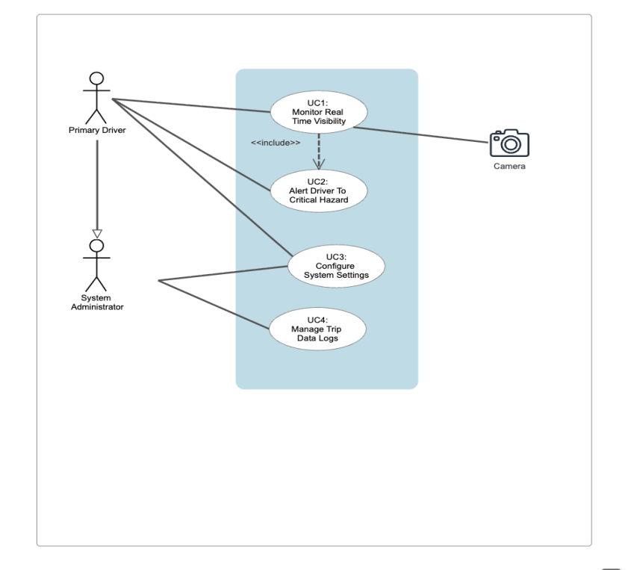

StoryBoard:
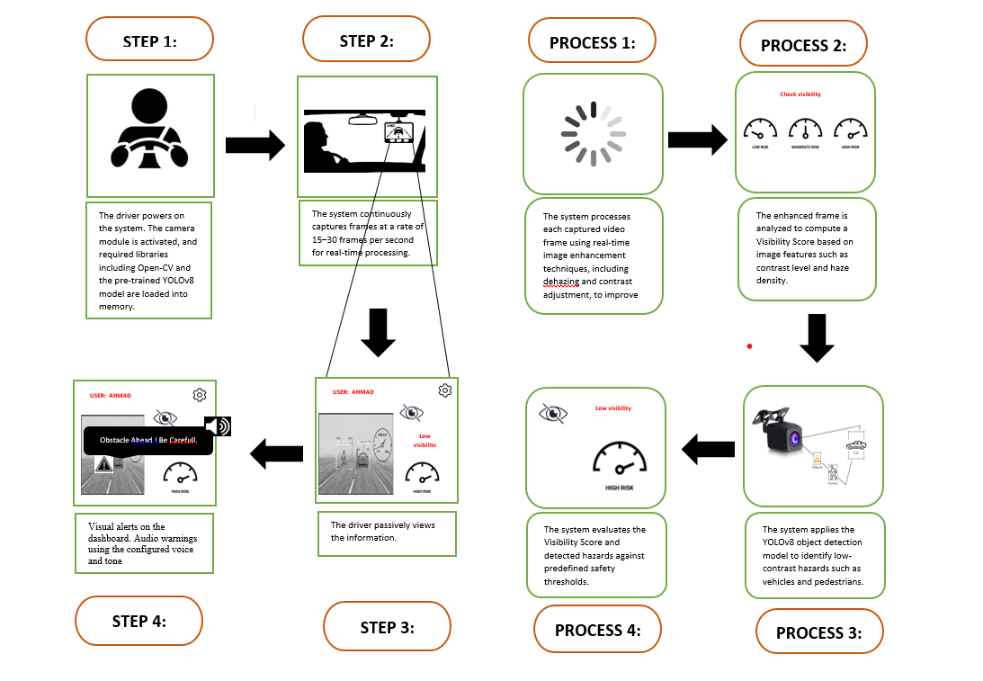
Figure 2: Storyboard

Operational Workflow and System Processing Storyboard:
The storyboard above illustrates the sequential flow of the "Smart Road Visibility System," divided into two parallel streams: the User Experience (Steps 1-4) and the internal System Processing (Processes 1-4).

Sequence A: User Interaction Flow (Left Column)
Step 1: System Initialization:
The interaction begins when the driver launches the application. Upon startup, the system activates the connected camera module and initializes the core software stack. This includes loading the OpenCV libraries for image processing and the pre-trained YOLOv8 deep learning model into memory to prepare for real-time inference.

Step 2: Real-Time Monitoring:
Once initialized, the dashboard displays the live feed. The system continuously captures video frames from the camera at a targeted rate of 15–30 Frames Per Second (FPS). This ensures that the driver receives a smooth, lag-free visual stream necessary for safe driving decisions.
Step 3: Passive Information Display:
Under normal driving conditions, the driver passively views the augmented dashboard. The screen presents a Dehazed Video Feed (cleared of smog artifacts) and a Visibility Meter that indicates the current risk level (e.g., "Low Visibility"). This allows the driver to gauge environmental conditions at a glance without being distracted.
Step 4: Active Alert Generation:
When the system detects an immediate threat, it transitions to active alerting. The interface flashes a visual warning (e.g., "Obstacle Ahead! Be Careful") directly on the screen, simultaneous with an Audio Warning. The tone and volume of this warning are determined by the user's pre-configured settings to ensure the driver's attention is captured instantly.

Sequence B: Internal System Logic (Right Column)
Process 1: Image Enhancement Pipeline:
Simultaneously with the video capture, the system processes every individual frame. It applies real-time dehazing algorithms and contrast adjustment techniques to digitally remove smog artifacts, effectively "cleaning" the image before it is displayed or analyzed.
Process 2: Visibility Computation:
The enhanced frame is passed to the analysis module, which computes a quantifiable Visibility Score. This score is derived from image features such as local contrast levels and haze density, categorizing the environment into Low, Moderate, or High Risk zones.
Process 3: Deep Learning Inference:
Parallel to visibility scoring, the YOLOv8 Object Detection model scans the frame for hazards. It specifically looks for low-contrast objects—such as stopped vehicles, pedestrians, or debris—that would otherwise be invisible to the naked eye in dense smog.
Process 4: Risk Evaluation & Trigger:
Finally, the system evaluates the data against predefined safety thresholds. If the Visibility Score drops below the critical limit or a hazard is identified with high confidence ($>85%), the system triggers the alert logic described in Step 4, completing the safety loop.

Summary:
The creation of the System Requirements Specification (SRS) for the AI-Powered Smart Road Visibility & Hazard Detection System is a crucial step in formalizing the project's scope and objectives. The requirements engineering process began by clearly identifying the User Classes (Private Drivers, Commercial Transport, Traffic Police) and their specific needs in low-visibility environments.
This SRS is anchored by seven core Functional Requirements (FR-1 through FR-7), which detail everything from User Authentication and Real-time Dehazing to Hazard Detection and Trip Data Logging. These functional requirements directly address the primary project objective: to provide a reliable, real-time warning system to prevent smog-related road accidents.
This SRS t also rigidly defines the necessary Non-Functional Requirements for Reliability(85% accuracy), Performance(15-30 FPS), Usability(simple GUI, easy setup), and Security (local processing).
The Use Case Analysis further refined these requirements into four detailed scenarios (UC1: Monitoring Real Time Visibility, UC2: Alert Drivers, UC3: Configure Safety Settings, UC4: Manage Trip Data Logging). By utilizing the formal Use Case Description tables and the accompanying (as included in your document), the system's external behavior has been clearly modeled, ensuring that the development phase will be tightly aligned with the user's safety and operational needs. The entire requirements process serves as a robust blueprint, validating the feasibility and necessity of this AI-powered solution for Pakistani road safety.

References:
[1] J. Redmon, S. Divvala, R. Girshick, and A. Farhadi, “You only look once: Unified, real-time object detection,” in Proceedings of the IEEE Conference on Computer Vision and Pattern Recognition (CVPR), Las Vegas, USA (optional): IEEE, 2016, pp. 779–788.
[2] Ultralytics, “YOLOv8 Documentation.” Accessed: Nov. 09, 2025. [Online]. Available: https://docs.ultralytics.com
[3] R. Ranftl, K. Lasinger, D. Hafner, K. Schindler, and V. Koltun, “Towards robust monocular depth estimation: Mixing datasets for zero-shot cross-dataset transfer,” IEEE Transactions on Pattern Analysis and Machine Intelligence (TPAMI), vol. 44, no. 3, pp. 1623–1637, Mar. 2022.
[4] M. Cordts, M. Omran, S. Ramos, and T. Rehfeld, “The Cityscapes dataset for semantic urban scene understanding,” in IEEE Conference on Computer Vision and Pattern Recognition (CVPR), IEEE, 2016, pp. 3213–3223.
[5] C. Sakaridis, D. Dai, and L. Van Gool, “Semantic foggy scene understanding with synthetic data,” International Journal of Computer Vision (IJCV), 2018.
[6] Provincial Police Department (Crime Branch) & Islamabad, “Death rate due to road traffic injuries – SDG3.” Accessed: Nov. 09, 2025. [Online]. Available: https://sdg3.nhsrc.pk/indicator_detail/61
[7] M. Hameed, “Contribution of road transport to Pakistan’s air pollution in the urban environment,” 2024.

